Date of Camp in Your Area:

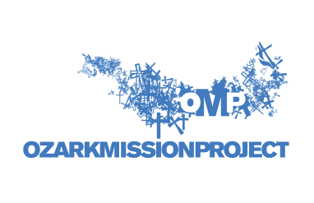
Staff Use Only
_____Days

A Non-Profit Corporation
Confidential Neighbor Application
Ozark Mission Project: P.O. Box 26525, Little Rock, AR 72221 501-664-3232

Name___________________________________________________Phone_____________________________________

Address____________________________________________________________________________________
Street City Zip Code
Directions to House___________________________________________________________________________
___________________________________________________________________________________________

If Not Homeowner, Owner’s Name___________________________ Phone ____________________________________

Homeowner’s Address_______________________________________________________________________________

Work Requested: (if other, please explain) _______________________________________________________________
__________________________________________________________________________________________________
☐ Interior Painting ☐ Porch Construction or Repair ☐ Wooden or Concrete Steps
☐ Exterior Painting and/or Repair ☐ Wheelchair Ramp Construction or Repair ☐ Handrails
☐ Yard Work & Trim ☐ Fence Repair ☐ Other
☐ House Work ☐ Window Screening

Can you help furnish materials? Yes ___ No ___
Are you a veteran? Yes ____ No ____
Are you over the age of 55? Yes ____ No ____
What are some things you enjoy doing or ways you enjoy serving your family, friends or neighbors? _________________
__________________________________________________________________________________________________
What family situation would be helpful for us to know? (illness, disabilities, etc.) ________________________________ __________________________________________________________________________________________________

Name of Referral Agency (if known) ___________________________________________________________________
Referral Agency Contact Name ___________________________________________Phone________________________

I understand that unskilled youth and adults will provide free labor to work on my home and that I shall receive no compensation from the use and/or the sale of any upgrade or project that OMP has put in place at this place of residence.

I agree that I will release any and all liability to Ozark Mission Project and any related agency, conference, district, local church, member, employee, volunteer, or agent, from any liability, injury, damage or loss, accidents, delay, or irregularity related to my participation or involvement in Ozark Mission Project and all work completed by OMP.

While my home is being repaired by OMP, I agree that I shall not, nor shall any resident of and visitor to my home, participate in the following activities: drug or alcohol use, weapon use, foul or abusive language directed at OMP staff or volunteers, or any activity that could cause harm to OMP staff or volunteers. I understand that if any of these behaviors occur, OMP reserves the right to stop work on my house, even if projects are left unfinished.

I authorize the use of any such photographic or electronic reproductions of me for any purpose, including, but not limited to print and other public media as may be deemed appropriate by Ozark Mission Project. (I understand that I may be identifiable from such photographic or electronic reproduction.)

____________________________________________________________________________________________________________
Signature of Homeowner Date

____________________________________________________________________________________________________________
Signature of Home Resident (if different than Homeowner) Date

STAFF USE ONLY BELOW
First Visit Date __________ Second Visit Date___________ Follow Up Visit Date__________

Job Completed Regret Sent Date____________

