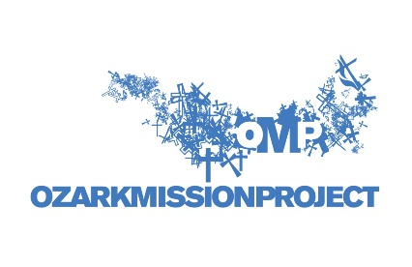
Job Title: Recruitment and Registration Manager
Reports To: Program Director

Overview
The Recruitment and Registration Manager is a full-time position that will oversee all aspects of working with youth group contacts and campers in preparation for their summer camp with Ozark Mission Project. This person will be responsible for the recruitment of campers, the registration process, and the completion of all camper paperwork. They will also serve as the staff liaison for the College Winter Trip Committee and OMP 101 Committee.
Responsibilities
- Responsible for meeting camper recruitment goals and metrics
- Update and monitor online registration service provider
- Maintain and update registration spreadsheet
- Create and send invoices to youth directors
- Keep track of all camp payments in eTapestry
- Collect and monitor all youth and adult camper required paperwork
- Conduct follow up calls with youth directors post camp
- Create end of camp surveys and share feedback with necessary individuals as needed
- Establish and cultivate relationships with youth directors, campers and volunteers
- Speak to church and community groups about our impact and funding needs
- Speak to Wesley Foundations about OMP college opportunities
- Produce and post content of all camp related social media
- Create and schedule all camp and volunteer related e-blasts
- Attend the Central AR Youth Director luncheons
- Oversee the College Winter Trip Committee and work with them to recruit participants and develop theme and worship activities
- Manage College Winter Trip registration, payments and paperwork
- Oversee the OMP 101 Committee and work with them to develop theme, plan program activities and connect with local partners for ministry
- Oversee OMP 101 logistics
- Establish OMP Ambassadors, conduct training and coordinate speaking opportunities
- Oversee Vacation Bible School coordination, curriculum and implementation
- Assist Program Director in recruiting, hiring and training College Staff
- Assist Program Director in recruiting and training Volunteers
- Assist Executive Director in fundraising events and initiatives
- Other duties as assigned
Qualifications
- Strong Christian faith
- Servant heart
- Ability and willingness to travel
- Reliable transportation
- Must have a valid driver’s license
- Team player
- Takes initiative
- Ability to adapt
- Ability to meet deadlines
- Ability to lift a minimum of 40 pounds
Required Experience & Skills
- Excellent written and verbal communication skills
- Outstanding presentation skills
- Microsoft Office and social media experience
- Organizational skills
- Time management skills
- Strong leadership skills
Preferred (Non-Required) Experience & Skills
- eTapestry experience
- MailChimp/Survey Monkey experience
- Construction knowledge and skills
- Graphic design experience
- OMP volunteer or camper experience
Location, Hours and Benefits
- Little Rock, AR
- Office hours are 8:30-4:30 Monday – Thursday (August-April); 8:30-4:30 Monday – Friday (May-July)
- Occasional nights and weekends are required
- Reimbursement for office travel
- Stipend for health insurance
- Vacation and sick time accrued
How to Apply
Send a cover letter and resume to Mallory Lindsey at info@ozarkmissionproject.org.
We are an equal employment opportunity employer. All qualified applicants will receive consideration for employment without regard to race, color, religion, gender, national origin, disability status, protected veteran status or any other characteristic protected by law.
Ozark Mission Project is a drug-free workplace. All offers of employment at OMP are contingent upon clear results of a thorough background check. Background checks will be conducted on all final candidates.

